1. Create a custom authentication node [or customize zero page login node]

Refer document here to create custom node:

https://backstage.forgerock.com/docs/am/7.1/auth-nodes/preparing-for-nodes.html

*boolean hasBlockID = false;*

*String BlockIDAuthn = context.request.servletRequest.getParameter("BlockIDAuthn");*

*System.out.println("1:" + context.request.servletRequest.getParameterValues("BlockIDAuthn"));*

*if(BlockIDAuthn!=null ) {*

*hasBlockID = true;*

*}*

*System.out.println("hasBlockID:" + hasBlockID );*

*Enumeration<String> params = context.request.servletRequest.getParameterNames();*

*while(params.hasMoreElements()){*

*String paramName = params.nextElement();*

*System.out.println("Parameter Name - "+paramName+", Value - "+ context.request.servletRequest.getParameter(paramName));*

*}*

*if(hasBlockID) {*

*System.out.println("Setting username:" + BlockIDAuthn );*

*System.out.println("Username obtained");*

*BlockIDSDK2 sdk = new BlockIDSDK2(null,null,null);*

*String decodedString = new String(Base64.getDecoder().decode(BlockIDAuthn.getBytes()));*

*System.out.println("decodedString:" +decodedString);*

*String userName = sdk.extractUsername(decodedString);*

*JsonValue sharedState = context.sharedState.copy();*

*JsonValue transientState = context.transientState.copy();*

*updateStateIfPresentForBlockID(context, true, config.usernameHeader(), USERNAME, sharedState,userName);*

*String realm = context.sharedState.get(REALM).asString();*

*System.out.println("Setting header");*

*return goTo(true)*

*.withUniversalId(identityUtils.getUniversalId(userName, realm, IdType.USER))*

*.replaceSharedState(sharedState).replaceTransientState(transientState).build();*

*}*

2. Custom node action process method should accept a parameter "BlockIDAuthn". Below mentioned code accepts the parameter and processes the result.

3. Put below jar files in <Forgerock home>/WEB_INF/lib.

bcpkix-jdk15on-1.63.jar bcprov-ext-jdk15on-1.63.jar bcprov-jdk15on-1.63.jar BlockIDCryptoHelper.jar java-json.jar

4. Put BlockIDECDSAHelper.java, BlockIDSDK2.java and blockid.properties in same package as custom node file.

Note: Please make sure blockid.properties has contents w.r.t to environment. Public & Private keys, licensekey and tenant details would change from customer to customer.

5. Save and compile custom node, BlockIDSDK2.java , BlockIDECDSAHelper.java and blockid.properties.

6. Package class files and properties file in auth-nodes-7.1.0.jar.

7. Copy auth-nodes-7.1.0.jar in <Forgerock home>/WEB_INF/lib.

8. Restart tomcat server.

9. Login to Forgerock AM using amadmin.

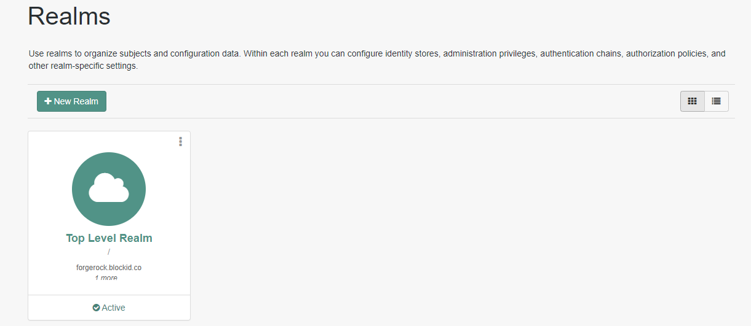

10. Choose your realm.

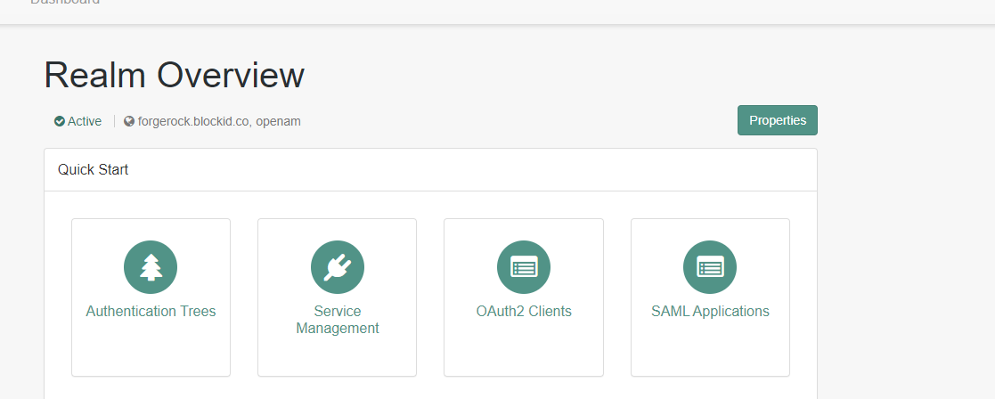

11. Click on authentication trees.

12. Click create new tree.

13. Create a new tree with custom node created.

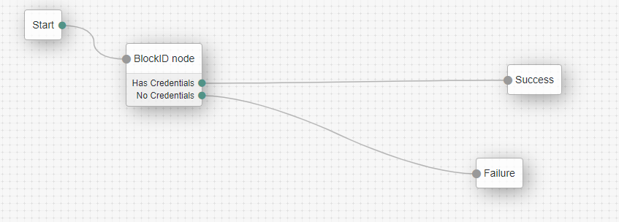

14. Follow below guide to start customizing UI.

<https://backstage.forgerock.com/docs/am/7/ui-customization-guide/ui-customizing-layout.html>

15. Open <FORGEROCK_HOME>/XUI/index.html

Add below value in header:

<script type="text/javascript" src="https://uwldemo.blockid.co/demo3/phpsdk/blockid.js"></script>

Above URL is only for example. Actual value may differ based on where sdk is hosted.

16. Open DataStore1.html

<FORGEROCK_HOME>/XUI/themes/default/templates/openam/authn/DataStore1.html

17. Add below div anywhere to display QR code.

<div id="qrcode" style="z-index: 1;position:relative;margin:10px" align="center">

18. Add below script as well.

<script type="text/javascript">

function createSession() {

createNewSession("Fingerprint", "firstname,did,userIdList", "qrcode",null

, function(result, error) {client_dataRecieved(result)}

)

}

function client_dataRecieved(result) {

let str = JSON.stringify(result, null, 4);

var aurl="http://forgerock.blockid.co/XUI/?realm=/&service=BlockIDTree&BlockIDAuthn="+window.btoa(str);

window.location.href = aurl;

}

createSession();

</script>

19. Save and close file.

20. Deploy UI changes using “yarn build”. Go to directory “am-external/openam-ui/openam-ui-user”. Run “yarn build” command. Copy contents of entire “am-external/openam-ui/openam-ui-user/build” directory and paste into <FORGEROCK_HOME>/XUI directory.

21. Refresh the ForgeRock AM login page.

